**Study Rationale**

This experiment is a follow-up to Experiment 2 from the same project (<https://osf.io/6kj8t/>). In Experiment 2, we found faster accumulation rates for lures in the target-inconsistent region (tortoises) compared to lures in the target-consistent region (turtles). This suggests that although evidence accumulation across the entire visual field is mandatory even when scene context is available, accumulation times can be sped up for lures in target-inconsistent regions. However, this speed-up could be due to the fact that the target-lure similarity was lower for lures in the target-inconsistent region compared to the target-consistent region. That is to say, it could be possible that scene context does not benefit search times in efficient search and that the shorter evidence accumulation times for lures in the target-consistent region was in fact due to them having a lower lure-target similarity.

Thus, in this experiment we will swap the target-consistent region with the target-inconsistent region. Now, the target (green turtle) will only appear on the beach. Lures in the target-consistent region will now be low-similarity (black tortoises), while lures in the target-inconsistent region will now be high-similarity (black turtle). If it is the case that accumulation times can be sped up for lures in target-inconsistent regions, we should see a similar pattern of results as Experiment 2. That is, the logarithmic slopes for lures in the target-inconsistent region (turtles in the water) will be less steep despite their higher lure-target similarity. On the other hand, if the speed up was simply due to target-lure similarity, then the steepness of the logarithmic functions will be modulated by lure-target similarity.

**Design**

The experiment will be identical to Experiment 3, other than the fact that (1) now the target green turtle will always appear on the beach rather than the water and (2) the instructions will be modified to reflect this:

*Welcome!*

*You will be searching for a green turtle in a scene of black turtles and black tortoises.*

*Turtles will always be in the sea, while tortoises will always be on land.*

*However, the green turtle will always be on land.*

*Your task is to decide which direction the turtle is facing.*

*You will see examples of the turtle on the following screens.*

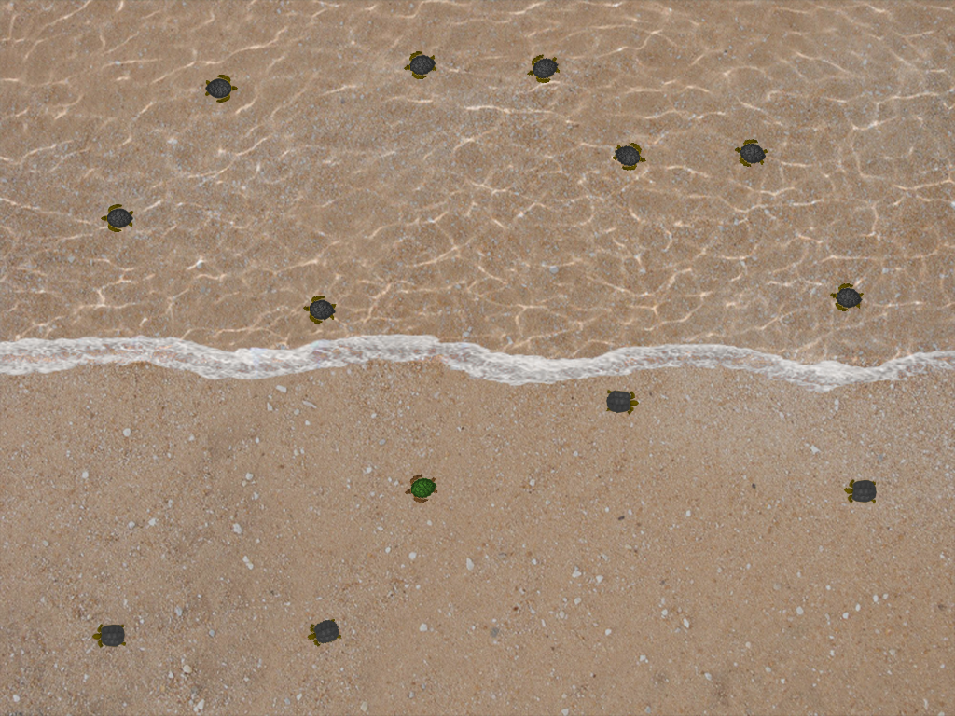

*Figure 1.* Example of a trial with set size 8 for the irrelevant region (sea) and set size 4 for the relevant region (land). Note that the set size refers only to the number of distractors.

**Exclusion criteria**

Before or during data collection:

1. If a researcher error occurs such as providing the participant with the wrong instructions or not properly setting up the experimental conditions (e.g. program or lighting conditions). Participants will be allowed to complete the study, but a note will be made in the experimental log sheet and the participant’s data will be excluded.
2. If the participant appears to be in an altered state due to being under the influence of a substance, or if they are extremely sleepy. A note will be made on the experimental log sheet and the participant’s data will be excluded.
3. If the participant is not following instructions, then they will be given a warning upon first notice and a note will be made on the experimental log sheet. The data from that participant will then be excluded.

After data collection:

1. Participants with error rates greater than 10% will be removed from analyses. This is the normal exclusion criteria used in many efficient search experiments, and is one that we have used previously.
2. Reaction times greater than 2000 will be assumed to be due to attentional lapses, and reaction times lesser than 200ms will be assumed to be due to anticipations (Wolfe, Palmer, & Horowitz, 2010).

**Analyses and hypotheses**

The dependent variables that will be collected are:

1. Reaction times
2. Accuracy

Since the main goal of this experiment is to examine whether items in target-inconsistent regions (i.e. turtles in the water while looking for turtles on land) are processed in efficient search, our measure of interest is reaction times.

**Participants**

Participants will be recruited from the student population of the University of Illinois at Urbana-Champaign. They will receive either course credit or monetary compensation. Only participants who have normal color vision will be recruited for the study.

A Sequential Bayes Factors approach will be taken with regard to the sample size (Schönbrodt, Wagenmakers, Zehetleitner, & Perugini, 2017). Starting with a minimal number of 20 participants (Schönbrodt et al., 2017), we will continue data collection until the effect of the irrelevant lures reaches BF10 = 3 or BF10 = 1/3. This would constitute “moderate” evidence for the alternative or null hypothesis respectively (Jeffreys, 1961; Kass & Raftery, 1995).